What are the shapes of the triangles?
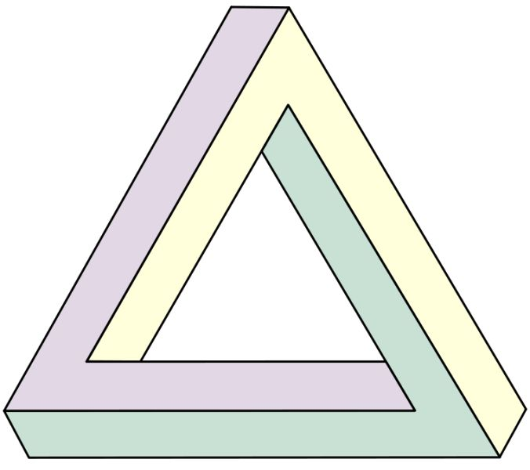
(1) Given 12, 15, 20 be the sides of the triangle ΔABC . If we use the altitudes h_{a}, h_{b} and h_{c} of ΔABC as lengths to construct another ΔXYZ. What kind of triangle is ΔXYZ ?

Method 1
$s=\frac{1}{2}\left(h_{a}+h_{b}+h_{c}\right)=\frac{1}{2}\left(12+15+20\right)=\frac{47}{2}$
By Heron Formula, the area of ΔXYZ , S is
$S=\sqrt{s\left(s-h_{a}\right)\left(s-h_{b}\right)\left(s-h_{c}\right)}=\sqrt{\frac{47}{2}\left(\frac{47}{2}-12\right)\left(\frac{47}{2}-15\right)\left(\frac{47}{2}-20\right)}=\frac{\sqrt{128639}}{4}$
Hence $h_{a}=\frac{2S}{12}=\frac{\sqrt{128639}}{6}, h_{b}=\frac{2S}{15}=\frac{2\sqrt{128639}}{15} ,h_{c}=\frac{2S}{20}=\frac{\sqrt{128639}}{10}$ ,
${h_{b}}^{2}+{h_{c}}^{2}={\left(\frac{2\sqrt{128639}}{15}\right)}^{2}+{\left(\frac{\sqrt{128639}}{10}\right)}^{2}=\frac{128639}{36}$
${h_{a}}^{2}={\left(\frac{\sqrt{128639}}{6}\right)}^{2}=\frac{128639}{36}$
${{∴ h}_{b}}^{2}+{h_{c}}^{2}={h_{a}}^{2}$
By the Converse of Pythagoras Theorem, ΔXYZ is a right angled triangle.
Obviously ΔXYZ is scalene, since all three sides h_{a}, h_{b} and h_{c} are different.

The calculation of the exact length of the altitudes may be difficult. A better method is shown below.

Method 2
Let S be the area of the triangle, then $S=\frac{1}{2}h_{a}\left(12\right)=\frac{1}{2}h_{b}\left(15\right)=\frac{1}{2}h_{c}\left(20\right)$
$h_{a}:h_{b}:h_{c}=\frac{1}{12}:\frac{1}{15}:\frac{1}{20}=\frac{60}{12}:\frac{60}{15}:\frac{60}{20}=5:4:3 ⟹ h_{a}=5k, h_{b}=4k, h_{c}=3k$
Since ${h_{b}}^{2}+{h_{c}}^{2}={\left(4k\right)}^{2}+{\left(3k\right)}^{2}=25k^{2}={h_{a}}^{2}$
By the Converse of Pythagoras Theorem, ΔXYZ is a right angled triangle.
Obviously ΔXYZ is scalene, since all three sides $h_{a}:h_{b}:h_{c}=5:4:3$and are different.

(2) Given that a , b and c are the three sides of ΔABC,
If $c^{2}\left(a^{2}+b^{2}-c^{2}\right)=b^{2}\left(c^{2}+a^{2}-b^{2}\right)$ , then what kind of triangle is ΔABC ?

$c^{2}\left(a^{2}+b^{2}-c^{2}\right)=b^{2}\left(c^{2}+a^{2}-b^{2}\right)$
$c^{2}a^{2}+b^{2}c^{2}-c^{4}-b^{2}c^{2}-{a^{2}b}^{2}+b^{4}=0$
$b^{4}-c^{4}-a^{2}\left(b^{2}-c^{2}\right)=0$
$\left(b^{2}+c^{2}\right)\left(b^{2}-c^{2}\right)-a^{2}\left(b^{2}-c^{2}\right)=0$
$\left(b^{2}-c^{2}\right)\left(b^{2}+c^{2}-a^{2}\right)=0$

(i) If $b^{2}-c^{2}=0$, $b^{2}=c^{2}$, $b=c$ , then ΔABC is isosceles.

(ii) If $b^{2}+c^{2}-a^{2}=0$, then $a^{2}=b^{2}+c^{2}$ .

By the Converse of Pythagoras Theorem, ΔABC is a right angled triangle with ∠ABC = 90º .

(3) In ΔABC, if $\frac{\cos{A+2\cos{C}}}{\cos{A+2\cos{B}}}=\frac{\sin{B}}{\sin{C}}$ , then what is the shape of the triangle ?

Method 1
Use Cosine Law and Sine Law for $\frac{\cos{A+2\cos{C}}}{\cos{A+2\cos{B}}}=\frac{\sin{B}}{\sin{C}}$
$\frac{\frac{b^{2}+c^{2}-a^{2}}{2bc}+2\frac{a^{2}+b^{2}-c^{2}}{2ab}}{\frac{b^{2}+c^{2}-a^{2}}{2bc}+2\frac{a^{2}+c^{2}-b^{2}}{2ac}}=\frac{b}{c}$
$\frac{a\left(b^{2}+c^{2}-a^{2}\right)+2c\left(a^{2}+b^{2}-c^{2}\right)}{a\left(b^{2}+c^{2}-a^{2}\right)+2b\left(a^{2}+c^{2}-b^{2}\right)}=\frac{b}{c}$
$ac\left(b^{2}+c^{2}-a^{2}\right)+2c^{2}\left(a^{2}+b^{2}-c^{2}\right)=ab\left(b^{2}+c^{2}-a^{2}\right)+2b^{2}\left(a^{2}+c^{2}-b^{2}\right)$
$a\left(b^{2}+c^{2}-a^{2}\right)\left(c-b\right)+2\left[a^{2}\left(c^{2}-b^{2}\right)-\left(c^{4}-b^{4}\right)\right]=0$
$\left(c-b\right)\left[a\left(b^{2}+c^{2}-a^{2}\right)+2\left(c+b\right)\left(a^{2}-c^{2}-b^{2}\right)\right]=0$
$\left(c-b\right)\left(b^{2}+c^{2}-a^{2}\right)\left(a-2b-2c\right)=0$
Since by Triangular Inequality, $2b+2c>2a>a⟹a-2b-2c≠0$.
$∴c=b or b^{2}+c^{2}=a^{2}$
Therefore ΔABC is an isosceles triangle or a right-angled triangle with ∠A as right-∠ .

Method 2
$\frac{\cos{A+2\cos{C}}}{\cos{A+2\cos{B}}}=\frac{\sin{B}}{\sin{C}}$
$\cos{A\sin{C+2\sin{C\cos{C=\cos{A\sin{B+2\sin{B\cos{B} }}}}}}}$
$\cos{A\sin{C+\sin{2C =\cos{A\sin{B+\sin{2B }}}}}}$
$\cos{A \left(\sin{C-\sin{B}}\right)+\left(sin 2C-sin{2B}\right)=0}$
$\cos{A \left[2cos \left(\frac{C+B}{2}\right) sin\left(\frac{C-B}{2}\right)\right]-2cos \left(C+B\right) sin\left(C-B\right)=0}$
$\cos{A \left[2cos \left(\frac{180°-A}{2}\right) sin\left(\frac{C-B}{2}\right)\right]-2cos \left(180°-A\right) sin\left(C-B\right)=0}$
$\cos{A \left[2sin \left(\frac{A}{2}\right) sin\left(\frac{C-B}{2}\right)\right]+2cos A\left[2sin\left(\frac{C-B}{2}\right)\cos\left(\frac{C-B}{2}\right)\right]=0}$
$2cos{A \sin\left(\frac{C-B}{2}\right)\left[sin \left(\frac{A}{2}\right)+2\cos\left(\frac{C-B}{2}\right)\right]=0}$
$\cos{A =0 or sin\left(\frac{C-B}{2}\right)=0 or sin \left(\frac{A}{2}\right)+2\cos\left(\frac{C-B}{2}\right)=0}$

(i) If $\cos{A=0}$, then $∠A=90°$ , ΔABC is a right-angled triangle.
(ii) If $\sin\left(\frac{C-B}{2}\right)=0$, then $\frac{C-B}{2}=0$ , $∠C=∠B$ and ΔABC is an isosceles triangle.
(iii) (a) $0°<\frac{A}{2}<90° ⟹ sin \left(\frac{A}{2}\right)>0$
(b) $-90°<\frac{C-B}{2}<90°⟹$ $2\cos\left(\frac{C-B}{2}\right)>0$
(c) $sin \left(\frac{A}{2}\right)+2\cos\left(\frac{C-B}{2}\right)≠0$

Yue Kwok Choy
25 June, 2015

